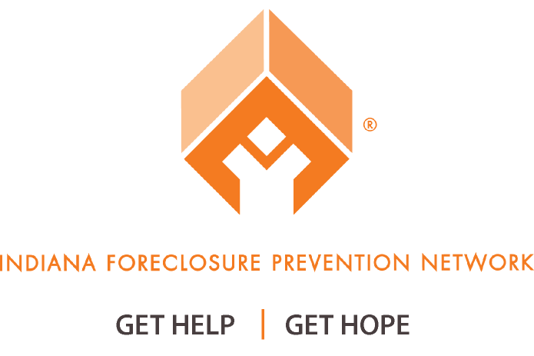
Frequently Asked Questions about the
Hardest Hit Fund Blight Elimination Program
Why should blighted or abandoned homes be demolished?
Blighted and/or abandoned homes have a negative impact on Indiana communities and neighborhoods. Blighted homes lower the property value of surrounding homes. Blighted homes also drain community resources and pose a danger to the surrounding neighborhoods. The goal is to demolish abandoned homes, and stabilize property values in Indiana communities. The partnership between Indiana Housing and Community Development Authority (IHCDA) and Indiana municipalities will allow communities to demolish blighted properties and offer a variety of end uses for the newly cleared properties including green space and redevelopment.
Where will Indiana obtain the funds to demolish blighted homes?
The funds will come from Indiana’s Hardest Hit Fund. The U.S. Department of the Treasury established the Housing Finance Agency Innovation Fund for the Hardest-Hit Markets (Hardest Hit Fund) to provide financial assistance to families in the states most impacted by the downturn of the housing market. The U.S. Department of the Treasury designed the overall program to give each participating state the flexibility to tailor its program to the unique factors contributing to its state’s foreclosure problems. Indiana received $221.7 million dollars in Hardest Hit Funds (HHF).
How has Indiana used its Hardest Hit Funds?
Of the $221.7 million Indiana received from the U.S. Department of the Treasury, $191.4 million was allocated for homeowner assistance. As of December 31, 2013, approximately $29.5 million dollars in mortgage payments have been paid on behalf of qualifying home owners. Another $63 million has been set aside to provide direct mortgage payment assistance to homeowners enrolled in the program. The IHCDA received Treasury approval to spend $75 million of the remaining funds to eliminate blight.
How will the Blight Elimination Program affect struggling homeowners?
IHCDA and the Indiana Foreclosure Prevention Network (IFPN) are committed to helping struggling homeowners. Indiana’s Hardest Hit Fund would remain a program that primarily provides homeowner assistance. The Hardest Hit Fund Blight Elimination Program would allow IHCDA and IFPN to further stabilize homeowner property values and increase safety in communities across Indiana.

How many blighted homes can be demolished through the Blight Elimination Program?
Approximately 4,000 blighted and/or abandoned homes could be demolished through the Blight Elimination Program.
What is the timeframe of the program?
IHCDA anticipates accepting applications to participate in the program as early as February 2014.
How will the program to demolish blighted homes work?
The State of Indiana has been divided into funding divisions for the purpose of implementing the Blight Elimination Program. Any municipality wishing to receive funds to demolish blighted homes would need to apply to IHCDA at www.877GetHope.org/blight. A municipality will not be awarded funds without applying. Municipalities will apply for funds from the funding division in which their county is located. More details will be provided, pending Treasury approval of the program.
What information will a city or town need to include in its application?
Applications should include: (1) A full and complete list of all properties the municipality seeks to demolish; (2) the end use of each lot post demolition; (3) estimates from licensed contractors which include legal removal of all debris and the backfill of basements or cellars using clean fill dirt; (4) financial and service contributions from community or neighborhood partners; and (5) community contributions to facilitate the demolition project.
Where can I obtain more information about the Blight Elimination Program?
Blight Elimination Program information is available at http://www.877GetHope.org/blight.
Where can I report a blighted home in my neighborhood?
Blighted or abandoned homes may be reported to feedback@ihcda.IN.gov.
Where can I provide input concerning the Blight Elimination Program?
Any comments, questions or concerns about the proposed Blight Elimination Program may be sent to feedback@ihcda.IN.gov.
Where can I learn more about Indiana’s HHF Programs?
Information about Indiana’s HHF programs may be found at www.877GetHope.org and www.in.gov/ihcda.

